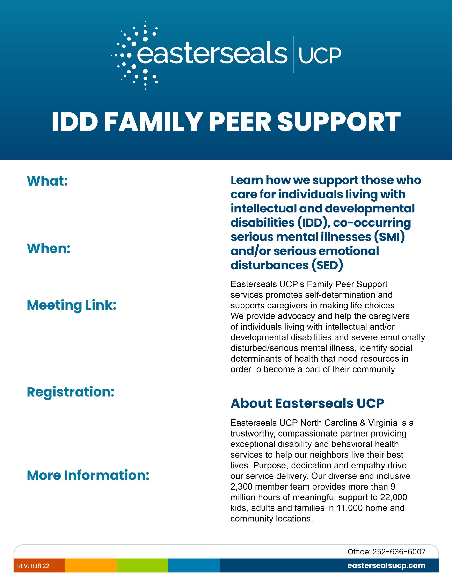





Virtual Support Group

First Saturday of the Month

Melinda Rhodes

252-670-0559

melinda.rhodes@eastersealsucp.com

2-4-2023 (Next meeting)

10:00am-11:30am